1. Create a C++ program to print following using manipulator functions: endl, setw( ), setfill ( ), setprecision( )

************************************************

| PES’s |

| Modern College Ganeshkhind |

| Computer Science Department |

| Subject : C++ |

| Roll No Percent Grade |

| 1 |

| 2 |

| 3 |

| 4 |

Code :-

#include <iostream>

using namespace std;

#include<iomanip>

int main() {

    cout<<setfill('*')<<setw(70);

    cout<<""<<endl;

    cout<<"|"<<setfill(' ')<<setw(30)<<"PES's"<<setfill(' ')<<setw(30)<<"|"<<endl;

    cout<<"|"<<setfill(' ')<<setw(40)<<"Modern College Ganeshkhind"<<setfill(' ')<<setw(20)<<"|"<<endl;

    cout<<"|"<<setfill(' ')<<setw(40)<<"Computer Science Department"<<setfill(' ')<<setw(20)<<"|"<<endl;

    cout<<"|"<<setfill(' ')<<setw(30)<<"Subject : C++"<<setfill(' ')<<setw(30)<<"|"<<endl;

    cout<<"|"<<setfill(' ')<<setw(30)<<"Roll No   Percent   Grade"<<setfill(' ')<<setw(30)<<"|"<<endl;

    cout<<"|"<<setfill(' ')<<setw(10)<<"1"<<setfill(' ')<<setw(50)<<"|"<<endl;

    cout<<"|"<<setfill(' ')<<setw(10)<<"2"<<setfill(' ')<<setw(50)<<"|"<<endl;

    cout<<"|"<<setfill(' ')<<setw(10)<<"3"<<setfill(' ')<<setw(50)<<"|"<<endl;

    cout<<"|"<<setfill(' ')<<setw(10)<<"4"<<setfill(' ')<<setw(50)<<"|"<<endl;

    cout<<"|"<<setfill(' ')<<setw(10)<<"5"<<setfill(' ')<<setw(50)<<"|"<<endl;

    cout<<"|"<<setfill(' ')<<setw(10)<<"6"<<setfill(' ')<<setw(50)<<"|"<<endl;

    cout<<"|"<<setfill(' ')<<setw(10)<<"."<<setfill(' ')<<setw(50)<<"|"<<endl;

    cout<<"|"<<setfill(' ')<<setw(10)<<"."<<setfill(' ')<<setw(50)<<"|"<<endl;

    cout<<setfill('*')<<setw(70);

    cout<<""<<endl;

    return 0;

}

Output-

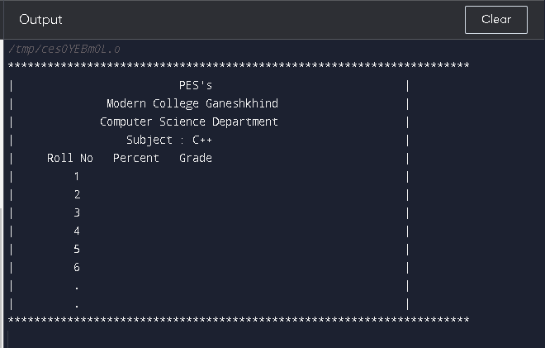

1. Write a C++ program to create array of objects of Book (id, title, author, price, publication) class. Read number of objects n from the user.

Sol:-

#include<iostream>

#include <string>

using namespace std;

class Book

{

  int id;

  char title[30];

  string author;

  float price;

  string publication;

  public:

  void getdata();//Declaration of function

  void putdata();//Declaration of function

};

void Book::getdata(){//Defining of function

  cout<<"Enter Id : ";

  cin>>id;

  cout<<"Enter title : ";

  cin>>title;

   cout<<"Enter author : ";

  cin>>author;

  cout<<"Enter price : ";

  cin>>price;

  cout<<"Enter publication : ";

  cin>>publication;

}

void Book::putdata(){//Defining of function

  cout<<"id="<<id<<endl;

  cout<<"title="<<title<<endl;

  cout<<"author="<<author<<endl;

  cout<<"price="<<price<<endl;

  cout<<"publication="<<publication<<endl;

  cout<<endl;

}

int main(){

  Book emp[30]; //One member

  int n,i;

  cout<<"Enter the number of books:";

  cin>>n;

  for(i=0;i<n;i++)

  {

  emp[i].getdata();//Accessing the function

  }

  for(i=0;i<n;i++)

  {

  emp[i].putdata();//Accessing the function

  }

  return 0;

}

OutPut

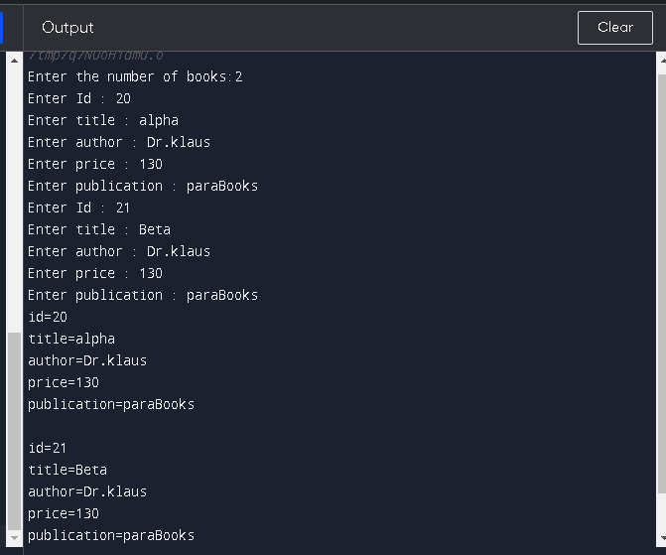

1. [Write C++ program to count number of alphabets, digits and special characters in string](https://techstudy.org/CplusplusLanguage/Write-Cplusplus-program-to-count-number-of-alphabets-digits-and-special-characters-in-string)

Sol-

#include <iostream>

#include <cctype>

using namespace std;

int main() {

    string str;

    int alphabets = 0, digits = 0, special_chars = 0;

    // Read the string

    cout << "Enter a string: ";

    getline(cin, str);

    // Iterate through each character in the string

    for (char c : str) {

        if (isalpha(c)) {

            // If the character is an alphabet, increment the alphabet count

            alphabets++;

        } else if (isdigit(c)) {

            // If the character is a digit, increment the digit count

            digits++;

        } else {

            // If the character is neither an alphabet nor a digit, it is a special character

            special_chars++;

        }

    }

    // Print the count of alphabets, digits, and special characters

    cout << "Number of alphabets: " << alphabets << endl;

    cout << "Number of digits: " << digits << endl;

    cout << "Number of special characters: " << special_chars << endl;

    return 0;

}

    // find_first_not_of function: searches for the first occurrence of a character not in the given string in the original string

    cout << "find_first_not_of('orl', 3, 3): " << str.find_first_not_of("orl", 3, 3) << endl;

    // find_last_of function: searches for the last occurrence of any character from the given string in the original string

    cout << "find_last_of('orl', 5, 3): " << str.find_last_of("orl", 5, 3) << endl;

    // find_last_not_of function: searches for the last occurrence of a character not in the given string in the original string

    cout << "find_last_not_of('orl', 5): " << str.find_last_not_of("orl", 5) << endl;

    // push_back function: adds the given character to the end of the string

    str.push_back('!');

    cout << "push_back('!'): " << str << endl;

    // pop_back function: removes the last character from the string

    str.pop_back();

    cout << "pop_back(): " << str << endl;

    return 0;

}

Output :-

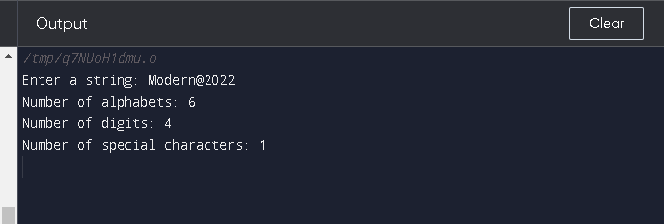

1. Write a C++ program to implement following string functions:

* substr(int position, int length)
* append(const string& str1)
* find(string& str1, int position, int len)
* find_first_of(string& str1, int position, int len)
* find_first_not_of(string& str1, int position, int n)
* find_last_of(string& str1, int position, int n)
* find_last_not_of(string& str1, int position)
* push_back(char c)
* pop_back()

Read the string from the user. Show the output of each function with proper message.

#include <iostream>

#include <string>

using namespace std;

int main()

{

    // Read the string from the user

    string str;

    cout << "Enter a string: ";

    getline(cin, str);

    // substr function: returns a substring of the given string

    cout << "substr(2, 5): " << str.substr(2, 5) << endl;

    // append function: appends the given string to the end of the original string

    string str1 = " World";

    str.append(str1);

    cout << "append(' World'): " << str << endl;

    // find function: searches for the given string in the original string and returns its position

    cout << "find('orld', 3, 4): " << str.find("orld", 3, 4) << endl;

    // find_first_of function: searches for the first occurrence of any character from the given string in the original string

    cout << "find_first_of('orl', 3, 3): " << str.find_first_of("orl", 3, 3) << endl;

    // find_first_not_of function: searches for the first occurrence of a character not in the given string in the original string

    cout << "find_first_not_of('orl', 3, 3): " << str.find_first_not_of("orl", 3, 3) << endl;

    // find_last_of function: searches for the last occurrence of any character from the given string in the original string

    cout << "find_last_of('orl', 5, 3): " << str.find_last_of("orl", 5, 3) << endl;

    // find_last_not_of function: searches for the last occurrence of a character not in the given string in the original string

    cout << "find_last_not_of('orl', 5): " << str.find_last_not_of("orl", 5) << endl;

    // push_back function: adds the given character to the end of the string

    str.push_back('!');

    cout << "push_back('!'): " << str << endl;

    // pop_back function: removes the last character from the string

    str.pop_back();

    cout << "pop_back(): " << str << endl;

    return 0;

}

Output

